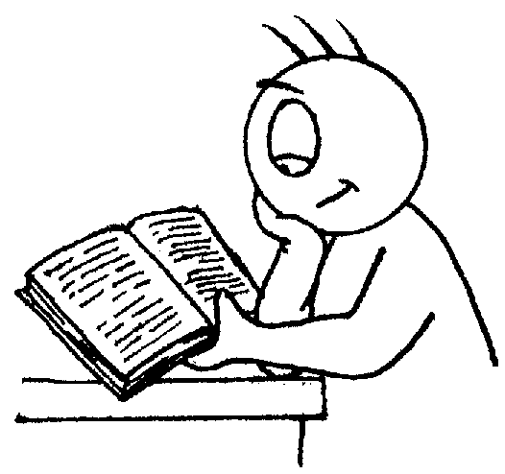

Writing

- Write clearly demarcated sentences.
- Use ‘and’ to join ideas.
- Use conjunctions to join sentences (e.g. so, but).
- Use standard forms of verbs, e.g. go/went.
- Evidence of:
- Capital letters.
- Full stops.
- Question marks.
- Exclamation marks.
- Use capital letters for names & personal pronoun ‘I’.
- Write clearly sequenced sentences.
- Correct formation of lower case – finishing in right place.
- Correct formation of capital letters.
- Correct formation of digits.
Reading

- Identify which words appear again and again.
- Relate reading to own experiences.
- Re-reads if reading does not make sense.
- Re-tell with considerable accuracy.
- Discuss significance of title & events.
- Make predictions on basis of what has been read.
- Make inferences on basis of what is being said & done.
- Reads with pace & expression, i.e. pause at full stop; raise voice for question
- Knows difference between fiction and non-fiction texts.

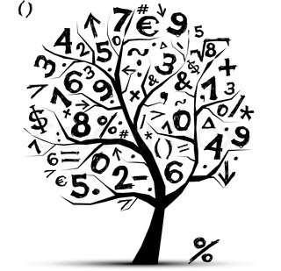
Mulberry Canon Barnett
Primary School



End of Year Expectations
for Year 1

This booklet provides information for parents and carers on the end of year expectations for children in our school. The staff have identified these expectations as being the minimum requirements your child must meet in order to ensure continued progress throughout the following year.

All the objectives will be worked on throughout the year and will be the focus of direct teaching. Any extra support you can provide in helping your children to achieve these is greatly valued.

If you have any queries regarding the content of this booklet or want support in knowing how best to help your child please talk to your child’s teacher.

Mathematics

- Count to & across 100, forwards & backwards from any number.
- Read & write numbers to 20 in digits & words.
- Read & write numbers to 100 in digits.
- Say 1 more/1 less to 100.
- Count in multiples of 1, 2, 5 & 10.
- Know bonds to 10 by heart.
- Use bonds & subtraction facts to 20.
- Add & subtract:
  - 1 digit & 2 digit numbers to 20, including zero.
- Add any three 1-digit numbers with a total up to 20.
- Solve simple multiplication & division with apparatus & arrays.
- Recognise half and quarter of object, shape or quantity.
- Sequence events in order.
- Use language of day, week, month and year.
- Tell time to hour & half past.

